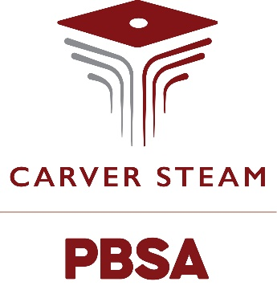

No Food Deliveries
Food cannot be delivered to students during the school day by food delivery establishments, including but not limited to Uber Eats, DoorDash, or GrubHub. This is to ensure the security of the school as well as to minimize disruptions to the school day. Also, students are NOT allowed to leave school to get food. Students found leaving school will face disciplinary consequences. Food delivered to students by outside delivery companies will be confiscated. In addition, parents/guardians may not bring or have outside food delivered to students during the school day.
If a student opens an outside door to allow an outside food delivery, they will face disciplinary consequences as this creates a security risk. ALL OUTSIDE FOOD DELIVERIES WHETHER BY A COMPANY OR PARENT/GUARDIAN WILL BE CONFISCATED AND NOT RETURNED.
If you have questions, please contact your student's grade level administrator.

